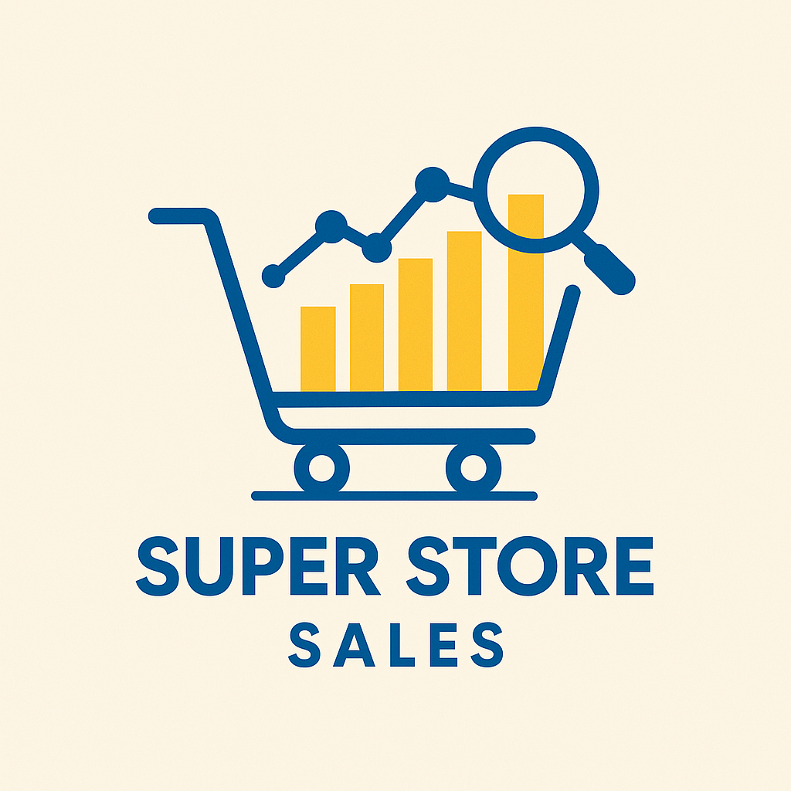 | Graduation Project  Initial Submission  Power BI engineer  CLS ONL2_DAT2_G3 | 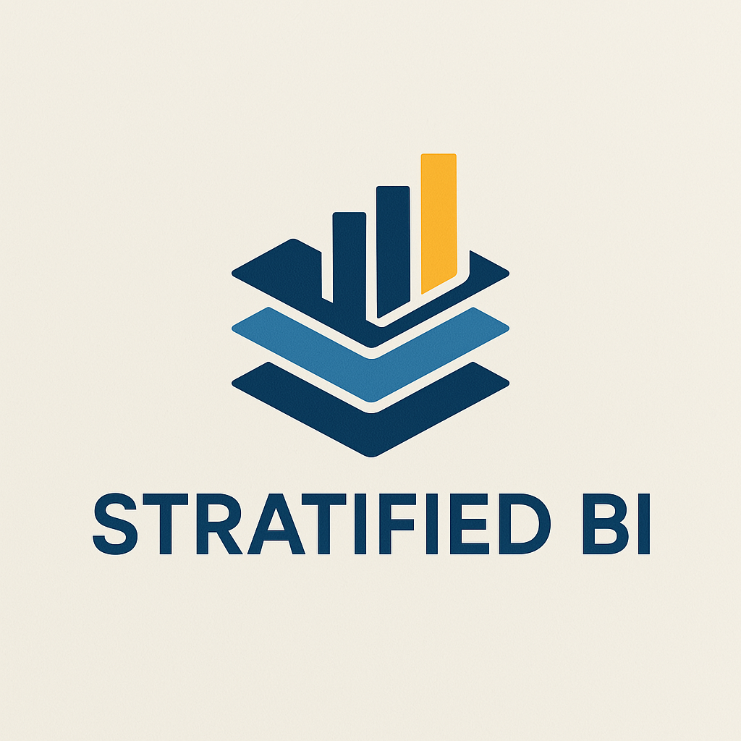
Sponsorship
Ministry of Communications and Information Technology
(MCIT) Egypt

Digital Egypt Pioneers Initiative
DEPI

Project Idea 1: Store Sales Dataset Analysis
Supervised by
Dr. Maged Magdy
Prepared by: CLS-PBI Data Analysis-G3
Enas Mokhtar Sayed Omar
Yahia Abdu Mohamed Ali
Hamed Ali Salem
Hytham Samir Abbas
Ibrahim Abd El-Salam Abd EL Mohsen
Selvia Gamil Gabriel
 | Graduation Project  Initial Submission  CLS-PBI Data Analysis-G3 | 



 | Graduation Project  Initial Submission  CLS-PBI Data Analysis-G3 | 
Project Idea 1: Store Sales Dataset Analysis
1. Team Name: CLS-PBI Data Analysis-G3
2. Selected Project: Project Idea 1: Store Sales Dataset Analysis
3. Team Leader: Hamed Ali Salem
The group:
No. | Full Name  in English | Full Name in Arabic | Student ID | Education Background | Governorate
1 | Yahia Abdu Mohamed Ali | يحيى عبده محمد علي | 21065640 | Licensee of English Art | Cairo
2 | Enas Mokhtar Sayed Omar | إيناس مختار سيد عمر | 21090529 | Bachelor of Pharmacy | New Valley
3 | Hamed Ali Salem | حامد علي سالم | 21097788 | Literature Faculty | Beni Suef
4 | Hytham Samir Abbas | هيثم سمير عباس | 21078552 | Police Academy | Beni Suef
5 | Ibrahim Abd El-Salam Abd EL Mohsen | ابراهيم عبد السلام عبد المحسن | 21072495 | Bachelor of Science | Menofia
6 | Selvia Gamil Gabriel | سيلفيا جميل غوبريال | 21084974 | Bachelor of Arts English department  Master in business administration | Cairo

Tools Selected: Excel, Power Bi

Build Data Model, Data Cleaning and Preprocessing

We selected tools like: Excel, Power Bi.

1- we import data of super store sales csv into power bi.
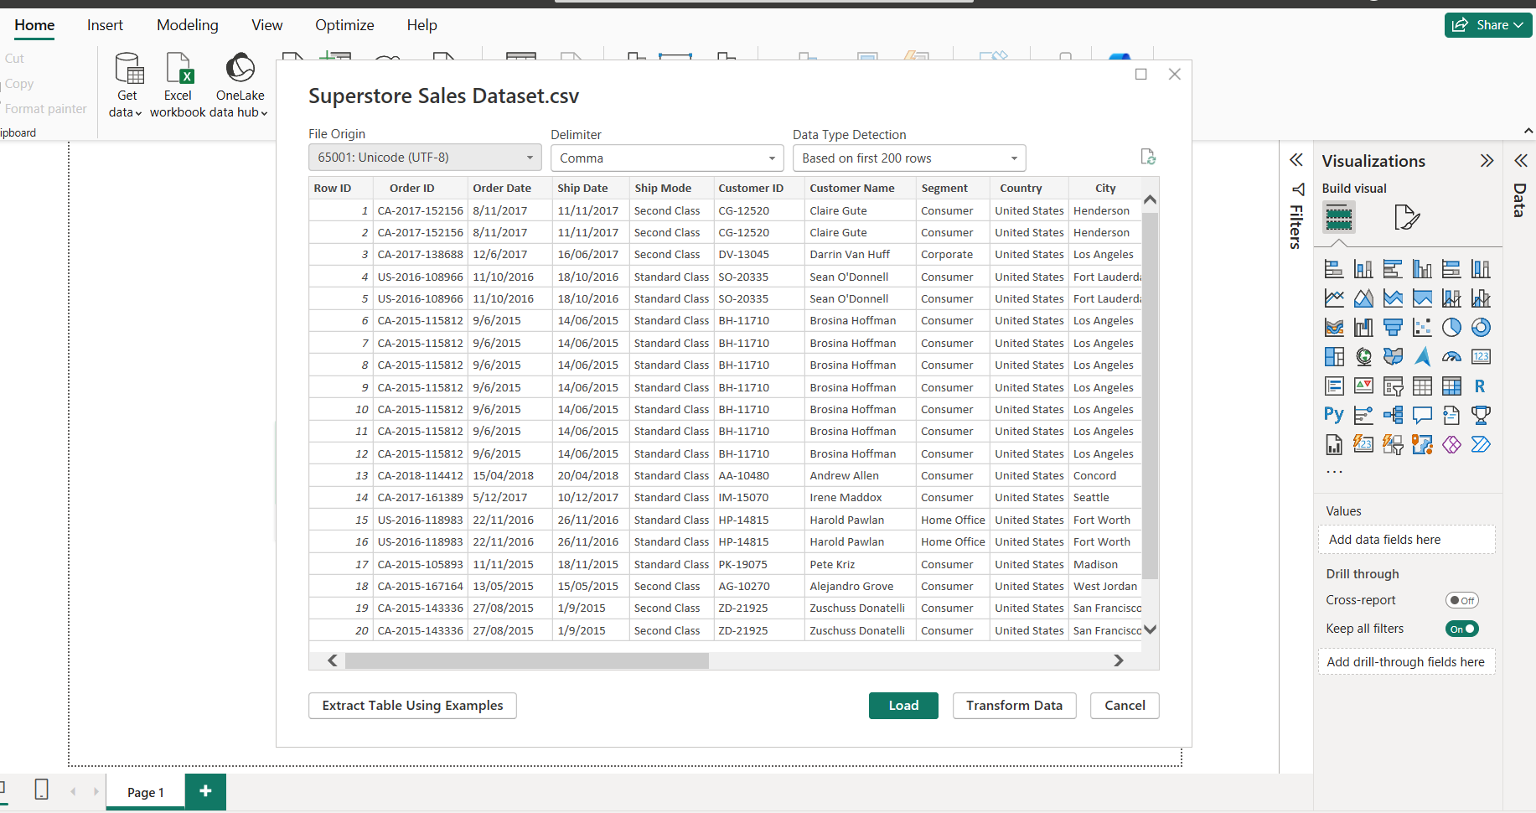

2- we select transform data to open power query for data cleaning.

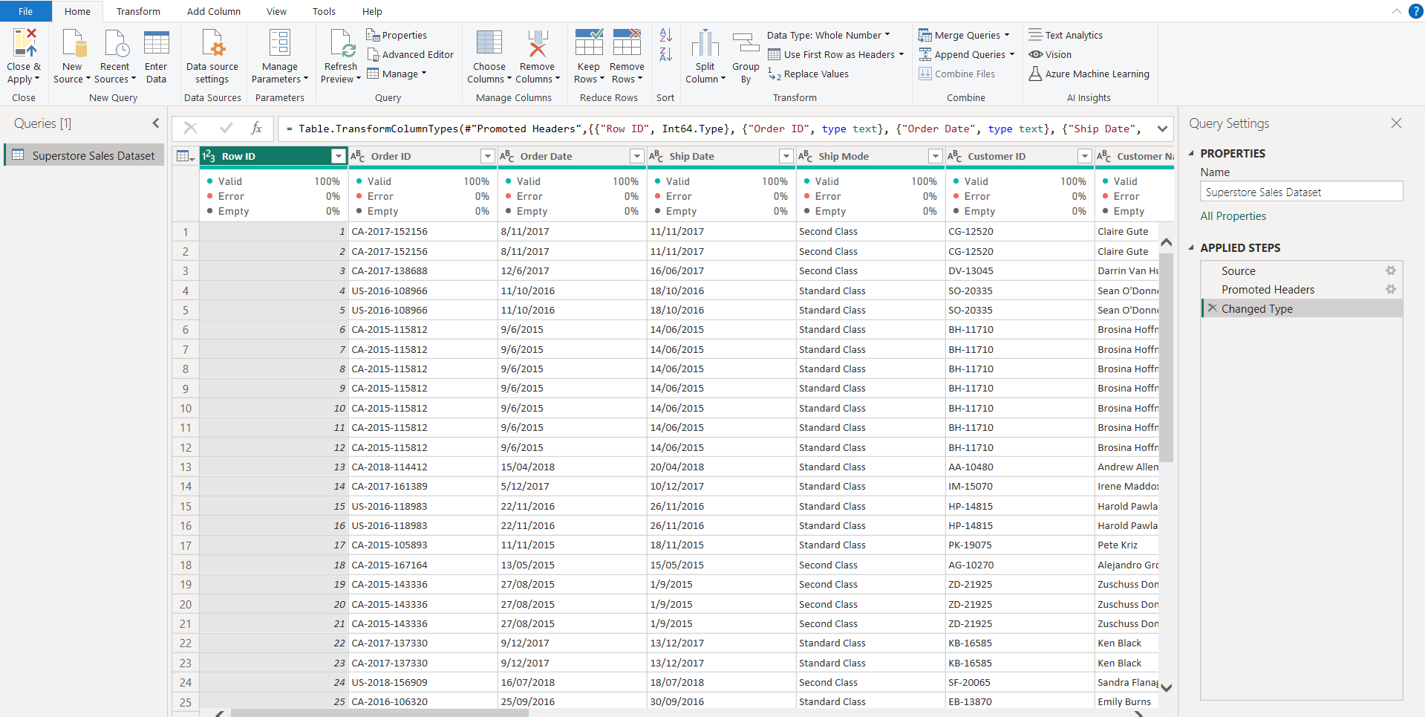
3- A screen of applied steps in query per column, like:
Change type with local, capitalize each word, trim text, clean text. &filter rows of postal code column to remove empty.

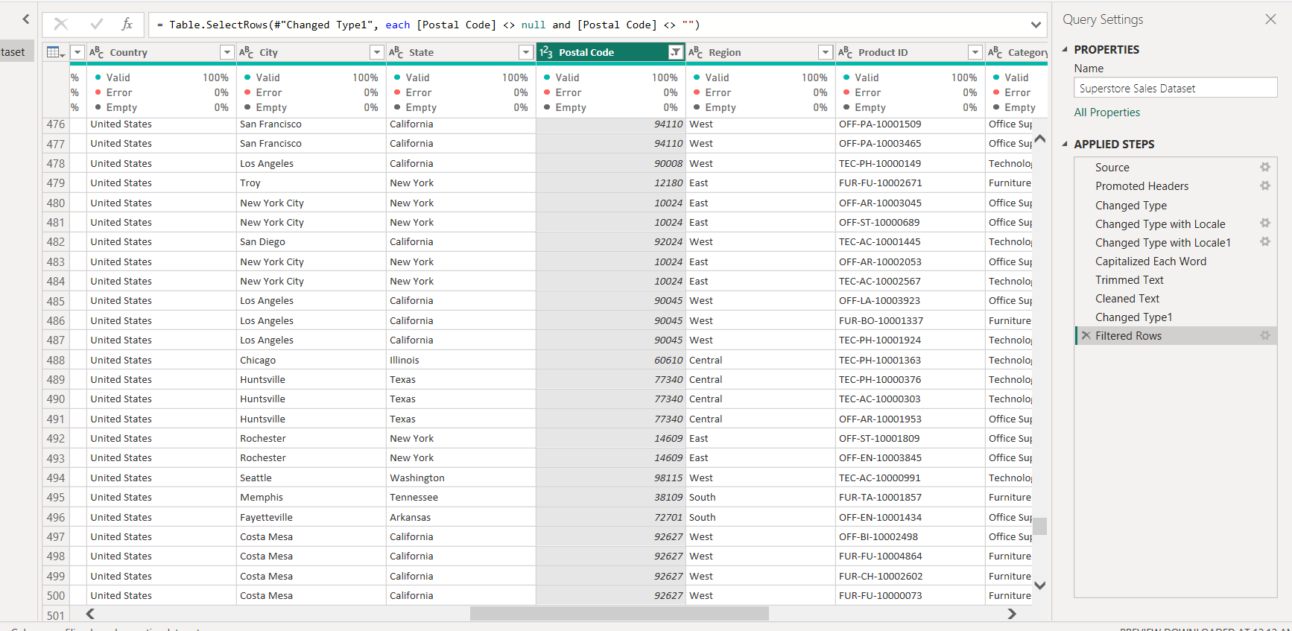
4- We make dimensions for (customer-product)
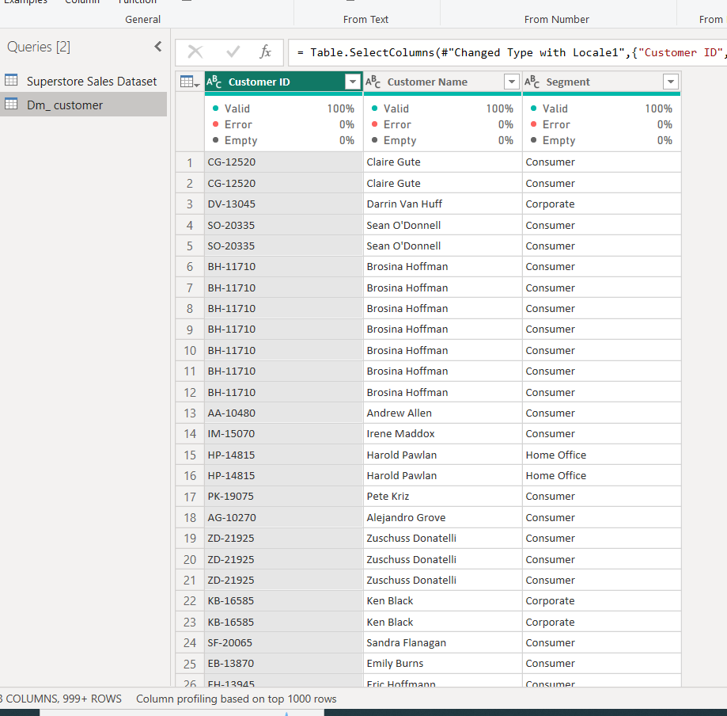
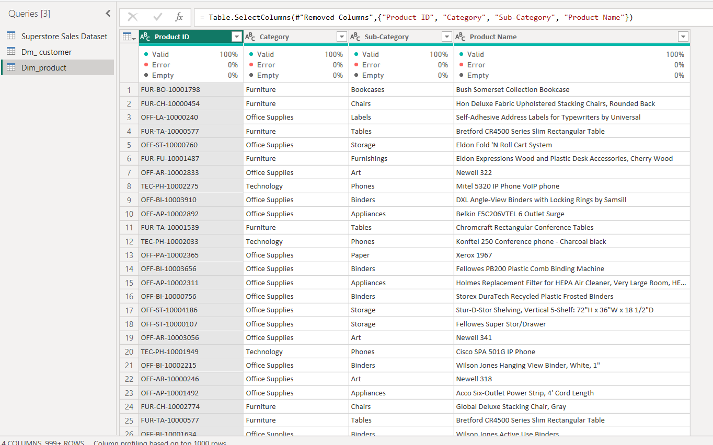

5- We added a new column “location ID” to add unique column for location to make location _dim
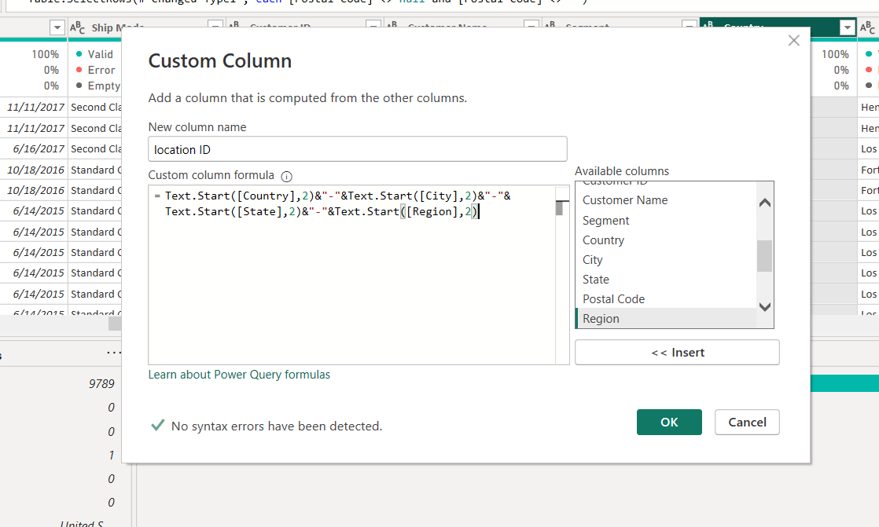

6- we collect all location data in location _dimension
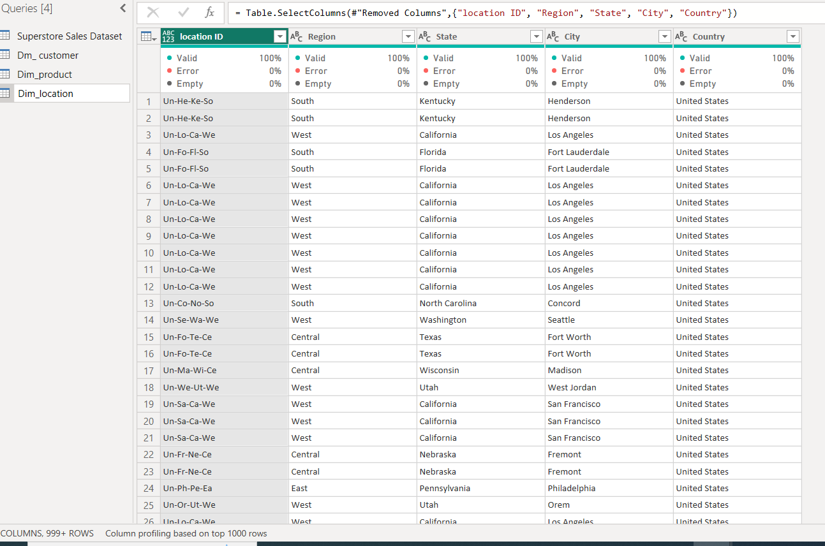
That is the final transformation in power query

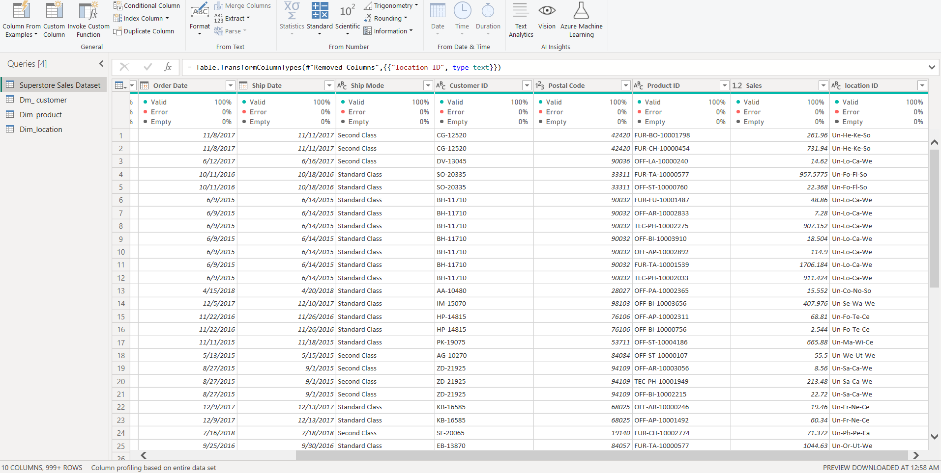
6-Then we press close & apply to load transformed data into power bi.

- We add measuring table through function (_measure=)

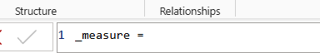

- We Create Calendar table for all dates data.

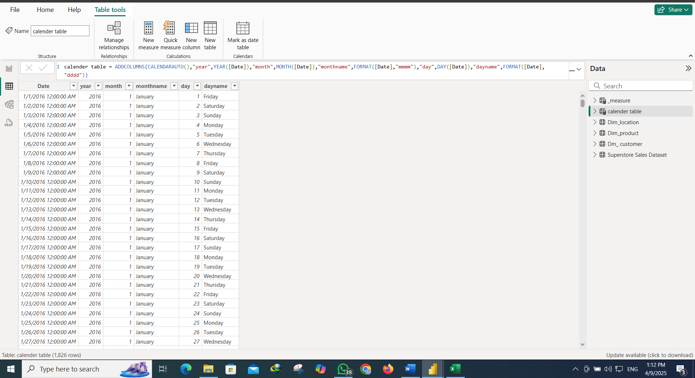

- We create data modeling to join all tables
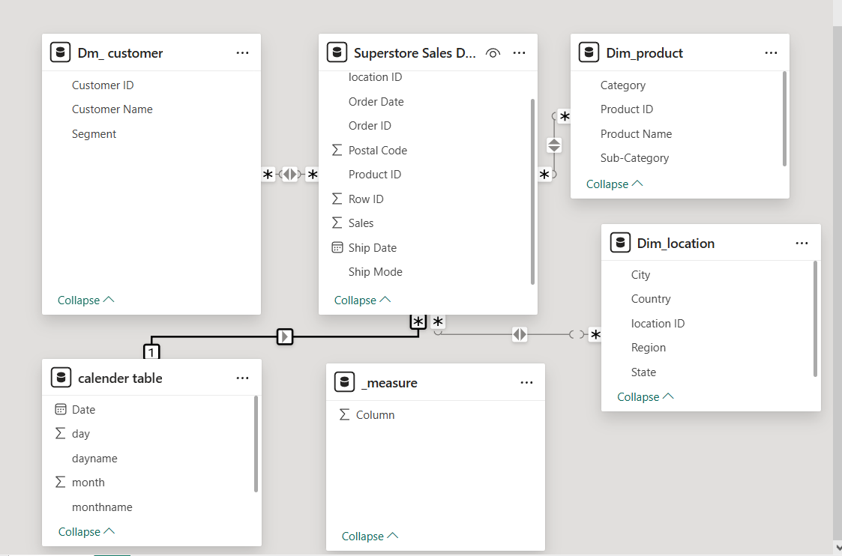

BUSSINESS QUESTION

📊 Sales Performance
- What are the total sales, product numbers, and growth rate?
- Which product categories and sub-categories have the highest and lowest sales?
- How does sales performance vary by ship mode?
- What are the top 10 best-selling products by sales?
- Which months or years show the highest and lowest sales performance?
- Is the current growth rate aligned with company targets?
👥 Customer Segmentation & Behavior
- Who are the top 10 customers contributing to overall sales?
- Which customer segments contribute the most to total revenue?
- Which regions contribute most to each customer segment’s sales?
- Which product categories are most popular among different customer segments?
- How have customer numbers changed over time (from 2015 to 2018) & Which months show the highest new customer acquisition or activity?
- Which segment has the highest sales growth, and how does it compare to the other segments?
- Can we forecast future sales using historical data trends?
📍 Regional & Geographical Analysis
- Which region achieved the highest total sales, and what percentage does it represent of overall sales?
- How balanced are category sales across different regions?
- Which cities generate the highest sales, and are there any cities consistently outperforming others?
- How are cities distributed across regions, and does the number of cities correlate with regional sales performance?
- How are sales distributed geographically across states and regions, and where are the sales hotspots?
- How has the sales distribution changed across states over the years?
ــــــــــــــــــــــــــــــــــــــــــــــــــــــــــــــــــــــــــــــــــــــــــــــــــــــــــــــــــــــــــــــــــــــــــــــــــــــــــــــــــــــــــــــــــــــــــــ
📊 Sales Performance
    - What are the total sales, product numbers, and growth rate?

- We format canvas background by changing color & insert shapes, icons, text box & write the title of the first page.

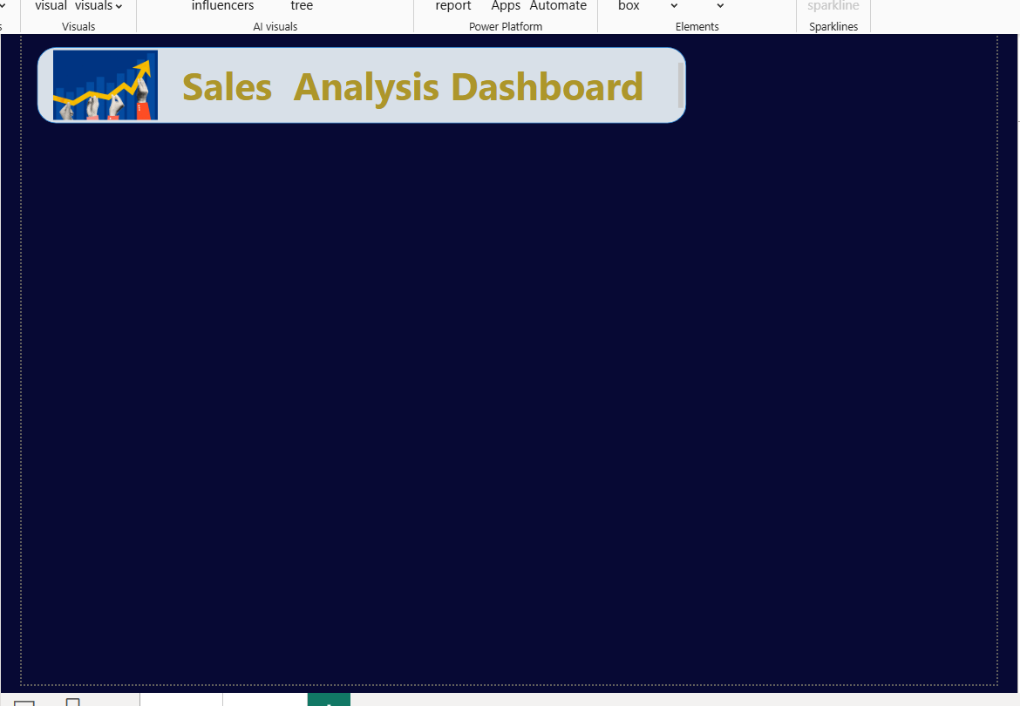
- We create measures of (Total Sales)

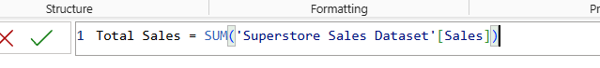
-selecting (card new) to show the measure in the dashboard, formatting the card and inserting icon that represent it.

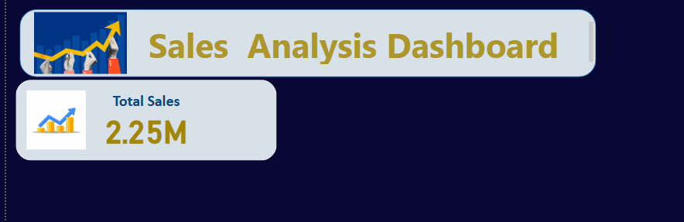
- We measure (Total number of products sold)

- We add the measure to card
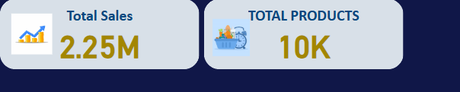
- We calculate sales last year (2017), sales current year (2018) then we calculate growth rate and add its value to the card as follows:
- 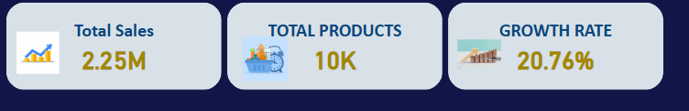

- We add slicer for (months- year – category)
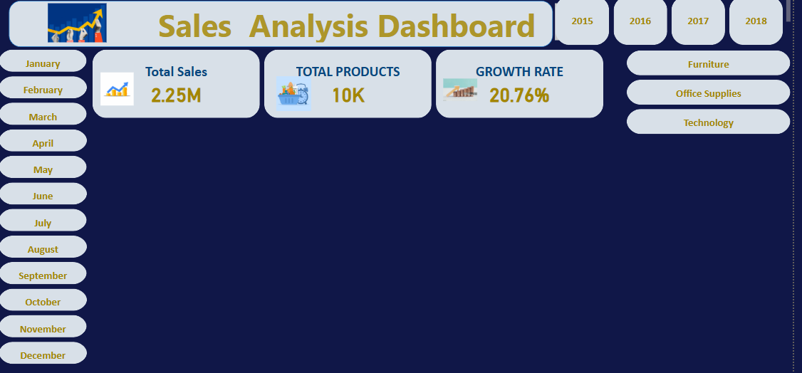
- 📝 Insight: Sales have reached a total of 2.25M and a 20.76% growth rate, reflecting a steady increase in performance year-over-year.
ـــــــــــــــــــــــــــــــــــــــــــــــــــــــــــــــــــــــــــــــــــــــــــــــــــــــــــــــــــــــــــــــــــــــــــــــــــــــــــــــــــــــــــــــــــــــــــــــــــــــــــــ
    - Which product categories and sub-categories have the highest and lowest sales?
- For subcategories, we choose clustered column charts to show the relation between total sales & subcategories.
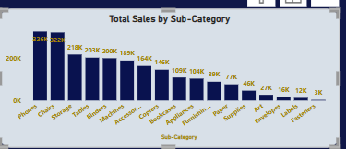

📝 Insight: Sub-categories like Phones and Chairs dominate sales, while items like Fasteners or Art Supplies have the lowest traction—potential areas to reassess inventory or marketing.

- For categories, we select a donut chart to show the relation between total sales & categories.

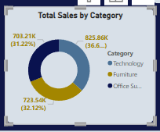

📝 Insight: The Technology category leads in total sales, followed by Office Supplies and Furniture, indicating a strong preference for tech-related products among customers.
ـــــــــــــــــــــــــــــــــــــــــــــــــــــــــــــــــــــــــــــــــــــــــــــــــــــــــــــــــــــــــــــــــــــــــــــــــــــــــــــــــــــــــــــــــــــــــــــ
    - How does sales performance vary by ship mode?
- We use a pie chart to show the relation between total sales & ship mode.
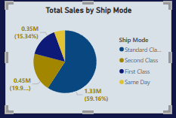

📝 Insight: The Standard Class shipping method is the most preferred by customers, likely due to cost-efficiency, while Same Day shipping has the least share.

5. Top 10 Best-Selling Products (Table)
ـــــــــــــــــــــــــــــــــــــــــــــــــــــــــــــــــــــــــــــــــــــــــــــــــــــــــــــــــــــــــــــــــــــــــــــــــــــــــــــــــــــــــــــــــــــــــــــ
    - What are the top 10 best-selling products by sales?
- We selected a table inserting products name (filtering top 10), last year’s sales, current year sales, total sales over the years & their growth rates over the years.
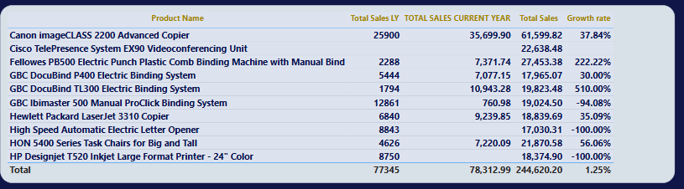
📝 Insight: These products consistently drive revenue and show a healthy year-over-year sales increase. Prioritizing stock availability and marketing for these items can maximize profits.
ــــــــــــــــــــــــــــــــــــــــــــــــــــــــــــــــــــــــــــــــــــــــــــــــــــــــــــــــــــــــــــــــــــــــــــــــــــــــــــــــــــــــــــــــــــــــــ
    - Which months or years show the highest and lowest sales performance?
- We select line chart inserting (month name) from calendar table in x -axis, total sales in y-axis and year in legend, formatting the chart and add data label that show sales for each month & year.
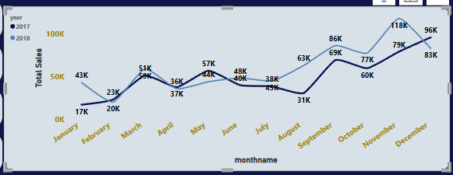

📝 Insight: Peak sales typically occur around November–December, likely driven by holiday shopping. Seasonal planning and promotions can capitalize on these trends.

ـــــــــــــــــــــــــــــــــــــــــــــــــــــــــــــــــــــــــــــــــــــــــــــــــــــــــــــــــــــــــــــــــــــــــــــــــــــــــــــــــــــــــــــــــــــــــــــــــــــــــــــ
    - Is the current growth rate aligned with company targets?

- We selected a gauge chart showing the Growth Rate = 20.76%. This metric is key to understanding performance improvement over time.
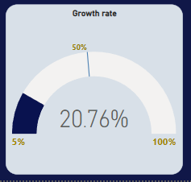

📝 Insight: With a 20.76% growth rate, performance is above average. This suggests that current strategies are effective, though additional analysis could determine if growth is sustainable.

ـــــــــــــــــــــــــــــــــــــــــــــــــــــــــــــــــــــــــــــــــــــــــــــــــــــــــــــــــــــــــــــــــــــــــــــــــــــــــــــــــــــــــــــــــــــــــــــ
👥 Customer Segmentation & Behavior
- We duplicate the sales page, change the title to be (customer insights) & add icon for customer.

- We measure (Total number of customer)
- We add the measure to (card new).
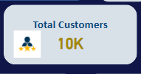
- We add a slicer for customer segment.

ــــــــــــــــــــــــــــــــــــــــــــــــــــــــــــــــــــــــــــــــــــــــــــــــــــــــــــــــــــــــــــــــــــــــــــــــــــــــــــــــــــــــ
    - Who are the top 10 customers contributing to overall sales

- We selected a clustered bar chart to show total sales of the top 10 customers`.
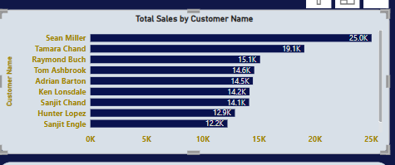

📝 Insight: These customers contribute significantly to overall revenue. Consider loyalty programs or personalized offers to retain and increase sales from this segment.

ـــــــــــــــــــــــــــــــــــــــــــــــــــــــــــــــــــــــــــــــــــــــــــــــــــــــــــــــــــــــــــــــــــــــــــــــــــــــــــــــــــــــــــــــــــــــــــــــ
    - Which customer segments contribute the most to total revenue?
- We selected a pie chart to show total sales of each segment.
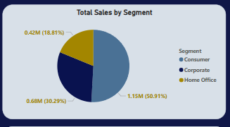

📝 Insight: Consumer and Corporate segments drive most sales. There may be an opportunity to grow the Home Office segment with targeted marketing.

ــــــــــــــــــــــــــــــــــــــــــــــــــــــــــــــــــــــــــــــــــــــــــــــــــــــــــــــــــــــــــــــــــــــــــــــــــــــــــــــــــــــــــ
    - Which regions contribute most to each customer segment’s sales?
- We selected a tree map chart to show customer segment sales contribution over different regions.
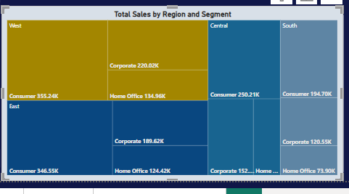

📝 Insight: Some segments perform better in specific regions. This information is key for tailoring regional campaigns and stocking strategies.

ــــــــــــــــــــــــــــــــــــــــــــــــــــــــــــــــــــــــــــــــــــــــــــــــــــــــــــــــــــــــــــــــــــــــــــــــــــــــــــــــــــــــــــــــــــــــــــ

    - Which product categories are most popular among different customer segments?
- We selected stacked column chart placed category in x axis, total sales in y axis & segment in legend.

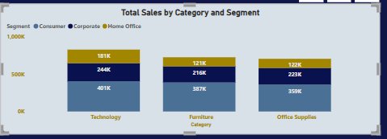

📝 Insight: Different segments prefer different product types—e.g., Consumers prefer Technology, while corporate buyers may lean towards Office Supplies.

ـــــــــــــــــــــــــــــــــــــــــــــــــــــــــــــــــــــــــــــــــــــــــــــــــــــــــــــــــــــــــــــــــــــــــــــــــــــــــــــــــــــــــــــــــــــــــــــ
    - How have customer numbers changed over time (from 2015 to 2018) & Which months show the highest new customer acquisition or activity?
- We selected a decomposition tree chart to show customer numbers over years & months.

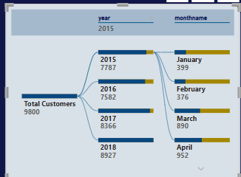

📝 Insight: The number of new customers increased steadily from 2015 to 2018, with spikes in Q4, again pointing to seasonal opportunities.

ـــــــــــــــــــــــــــــــــــــــــــــــــــــــــــــــــــــــــــــــــــــــــــــــــــــــــــــــــــــــــــــــــــــــــــــــــــــــــــــــــــــــــــــــــــــــــــــ
    - Which segment has the highest sales growth, and how does it compare to the other segments?
- We placed customer segment in the category field of funnel chart & growth rate in value field as follows: -

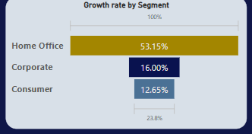

📝 Insight: The Consumer segment has the highest growth, making it a priority for future campaigns and product development.

ــــــــــــــــــــــــــــــــــــــــــــــــــــــــــــــــــــــــــــــــــــــــــــــــــــــــــــــــــــــــــــــــــــــــــــــــــــــــــــــــــــــــــــــــــــــــــــ
    - Can we forecast future sales using historical data trends?
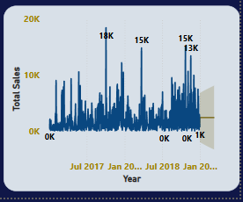
-ــــــــــــــــــــــــــــــــــــــــــــــــــــــــــــــــــــــــــــــــــــــــــــــــــــــــــــــــــــــــــــــــــــــــــــــــــــــــــــــــــــــــــــــــــــــــ
📍 Regional & Geographical Analysis
- We duplicate the page of customer insights & change the title of the page to be (Regional Dashboard) and add icon to represent region.

- We add a slicer for regions.
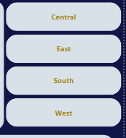
- We create a measure to calculate the number of cities & add it to card new .

ـــــــــــــــــــــــــــــــــــــــــــــــــــــــــــــــــــــــــــــــــــــــــــــــــــــــــــــــــــــــــــــــــــــــــــــــــــــــــــــــــــــــــــ
    - Which region achieved the highest total sales, and what percentage does it represent of overall sales?

- We have selected a pie chart to show total sales of each region & their percentage as follows: -
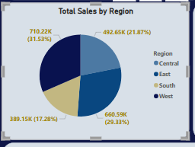
📝 Insight: The Central region contributes the most to total sales, suggesting it is a strategic area for marketing, logistics, and expansion.
ــــــــــــــــــــــــــــــــــــــــــــــــــــــــــــــــــــــــــــــــــــــــــــــــــــــــــــــــــــــــــــــــــــــــــــــــــــــــــــــــــــــــــــــــــــــــــــــ
    - How balanced are category sales across different regions?
- We selected line & clustered column charts to show sales of different categories across different regions.
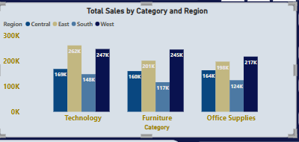

📝 Insight: Category preferences vary across regions. For example, Technology excels in the West, while Office Supplies are stronger in the East.

ـــــــــــــــــــــــــــــــــــــــــــــــــــــــــــــــــــــــــــــــــــــــــــــــــــــــــــــــــــــــــــــــــــــــــــــــــــــــــــــــــــــــــــــــــــــــــــــ
    - Which cities generate the highest sales, and are there any cities consistently outperforming others?
- We use the clustered bar chart to show total sales of top 5 cities across different regions as follows: -
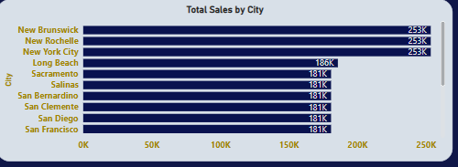

📝 Insight: Cities like New York and New Brunswick consistently outperform others. These can serve as benchmark cities for best practices.

ـــــــــــــــــــــــــــــــــــــــــــــــــــــــــــــــــــــــــــــــــــــــــــــــــــــــــــــــــــــــــــــــــــــــــــــــــــــــــــــــــــــــــــــــــــ
    - How are cities distributed across regions, and does the number of cities correlate with regional sales performance?
- We selected a donut chart to show the number of cities across regions.
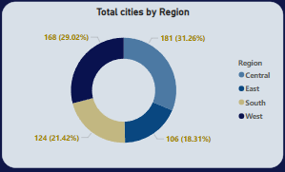

📝 Insight: Although the East has the most cities, it doesn’t lead in sales—suggesting rooms increasing penetration or improving performance per city.

ــــــــــــــــــــــــــــــــــــــــــــــــــــــــــــــــــــــــــــــــــــــــــــــــــــــــــــــــــــــــــــــــــــــــــــــــــــــــــــــــــــــــتــــــــــــــــــــ
    - How are sales distributed geographically across states and regions, and where are the sales hotspots?
- We selected a map to show sales of states across regions by placing (states) in the location field, (regions) in legend field & total sales in bubble field as follows: -

.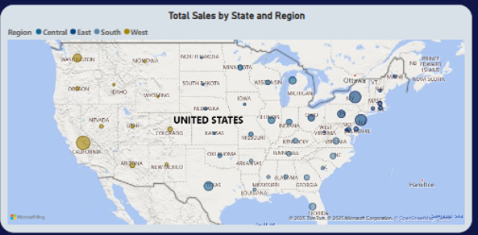

📝 Insight: California, New York, and Texas are major sales hotspots. Focus efforts on high-performing states and explore untapped regions.

ـــــــــــــــــــــــــــــــــــــــــــــــــــــــــــــــــــــــــــــــــــــــــــــــــــــــــــــــــــــــــــــــــــــــــــــــــــــــــــــــــــــــــــــــــــــــــــــ

    - How has the sales distribution changed across states over the years?

- We selected a decomposition tree chart to show sales of states over the years as follows:

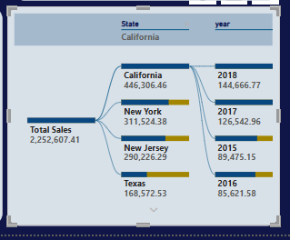

📝 Insight: State-level trends help identify which regions are growing or declining, useful for resource allocation and forecasting.

ـــــــــــــــــــــــــــــــــــــــــــــــــــــــــــــــــــــــــــــــــــــــــــــــــــــــــــــــــــــــــــــــــــــــــــــــــــــــــــــــــــــــــــــــــــــــــــــ
- We utilized bookmarks to enhance user interactivity and streamline navigation within the dashboards, so the analysis became more dynamic, user-friendly, and focused on storytelling through data.
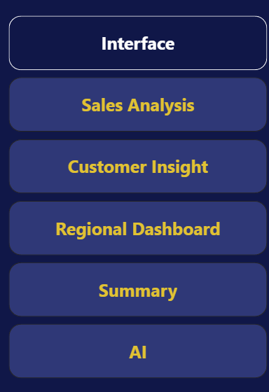

ـــــــــــــــــــــــــــــــــــــــــــــــــــــــــــــــــــــــــــــــــــــــــــــــــــــــــــــــــــــــــــــــــــــــــــــــــــــــــــــــــــــــــــــــــــــــــــــ

- We create an interface for the project that express it including (a related image- logo of project- logo of the team – bookmarks that represent dashboards name (sales analysis-customer insight – regional dashboard).

ـــــــــــــــــــــــــــــــــــــــــــــــــــــــــــــــــــــــــــــــــــــــــــــــــــــــــــــــــــــــــــــــــــــــــــــــــــــــــــــــــــــــــــــــــــــــــــــ
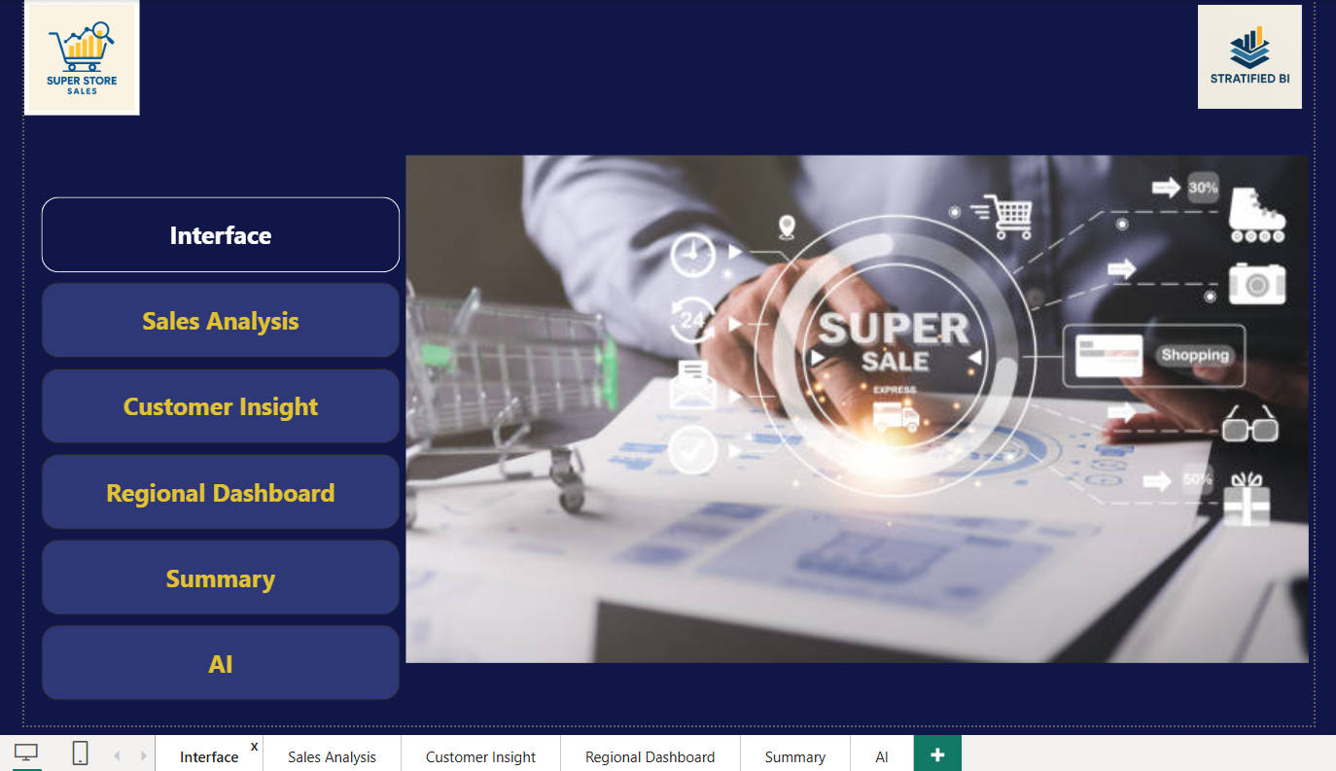
ـــــــــــــــــــــــــــــــــــــــــــــــــــــــــــــــــــــــــــــــــــــــــــــــــــــــــــــــــــــــــــــــــــــــــــــــــــــــــــــــــــــــــــــــــــــــــــــ
- We add a summary page

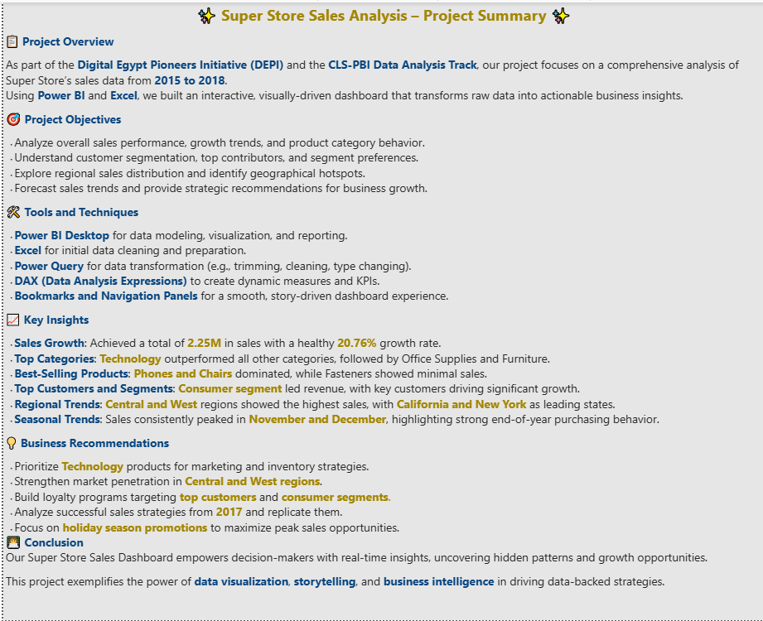
- We Interpret AI to answer any question related to the dashboard.

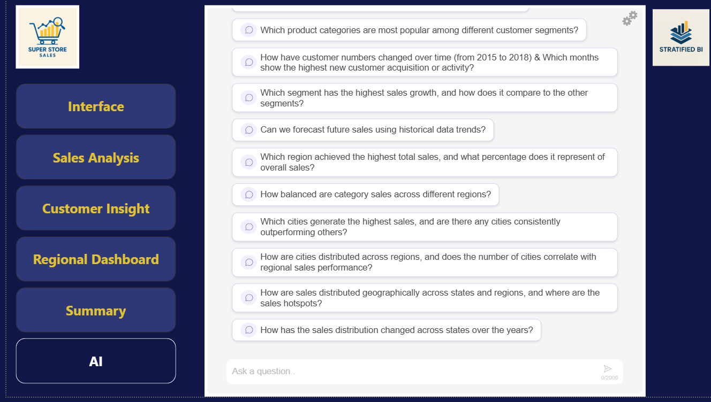
ـــــــــــــــــــــــــــــــــــــــــــــــــــــــــــــــــــــــــــــــــــــــــــــــــــــــــــــــــــــــــــــــــــــــــــــــــــــــــــــــــــــــــــــــــــــــــــــــ

